Fire alarm system

* Basic idea of the project :
* The main concept of the project is to detect flame and warn people from it.
* We used several components to build the system

such as :

1. Flame sensor module
2. Arduino uno
3. Indicators (LEDs & Buzzer)
4. Wires
5. breadBoard

Lets get started with Flame sensor…

* This module is sensitive to the flame and radiation. It also can detect ordinary light source in the range of a wavelength 760nm-1100 nm.
* The detection distance is up to 100 cm.
* The Flame sensor can output digital or analog signal.
* Describtion :
* Detection distance: 20cm (4.8V) ~ 100cm (1V)
* Adjustable detection range.
* VCC -- 3.3V-5V voltage
* GND -- GND
* DO -- board digital output interface (0 and 1)
* AO -- board analog output.
* **SOFTWARE \**
* First thing we create a new VI then open block diagram and Select ( open – close ), while loop and click right on serial port to create control that the user could enter it from Front panel
* Next we create 1 Digital read for the sensor and a couple of digital write for buzzers and LEDs.
* After that we do the most complex step in the code which was how to latch the signal from sensor by using Feedback node.
* Finally we create the stop button for the whole system.
* BLOCK DIAGRAM & FRONT PANEL

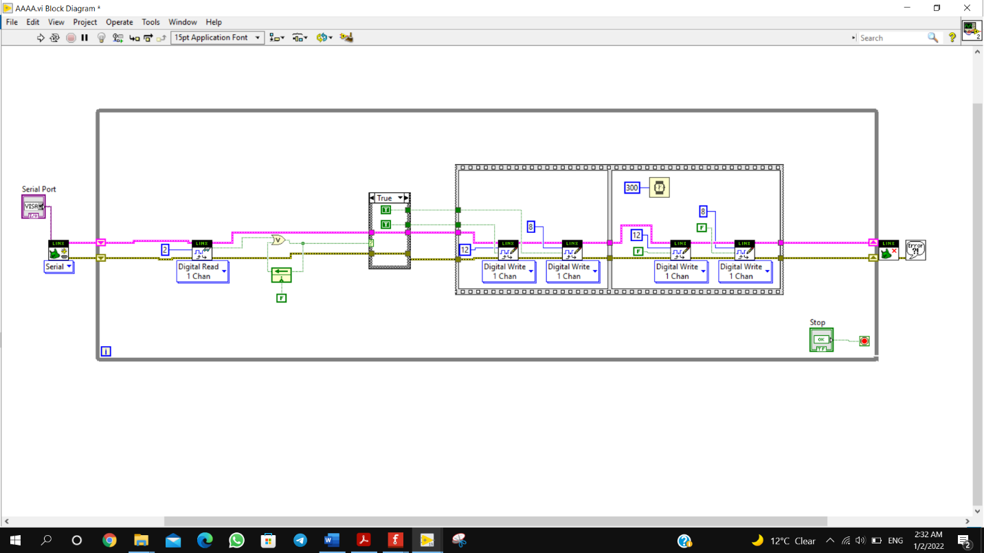

* 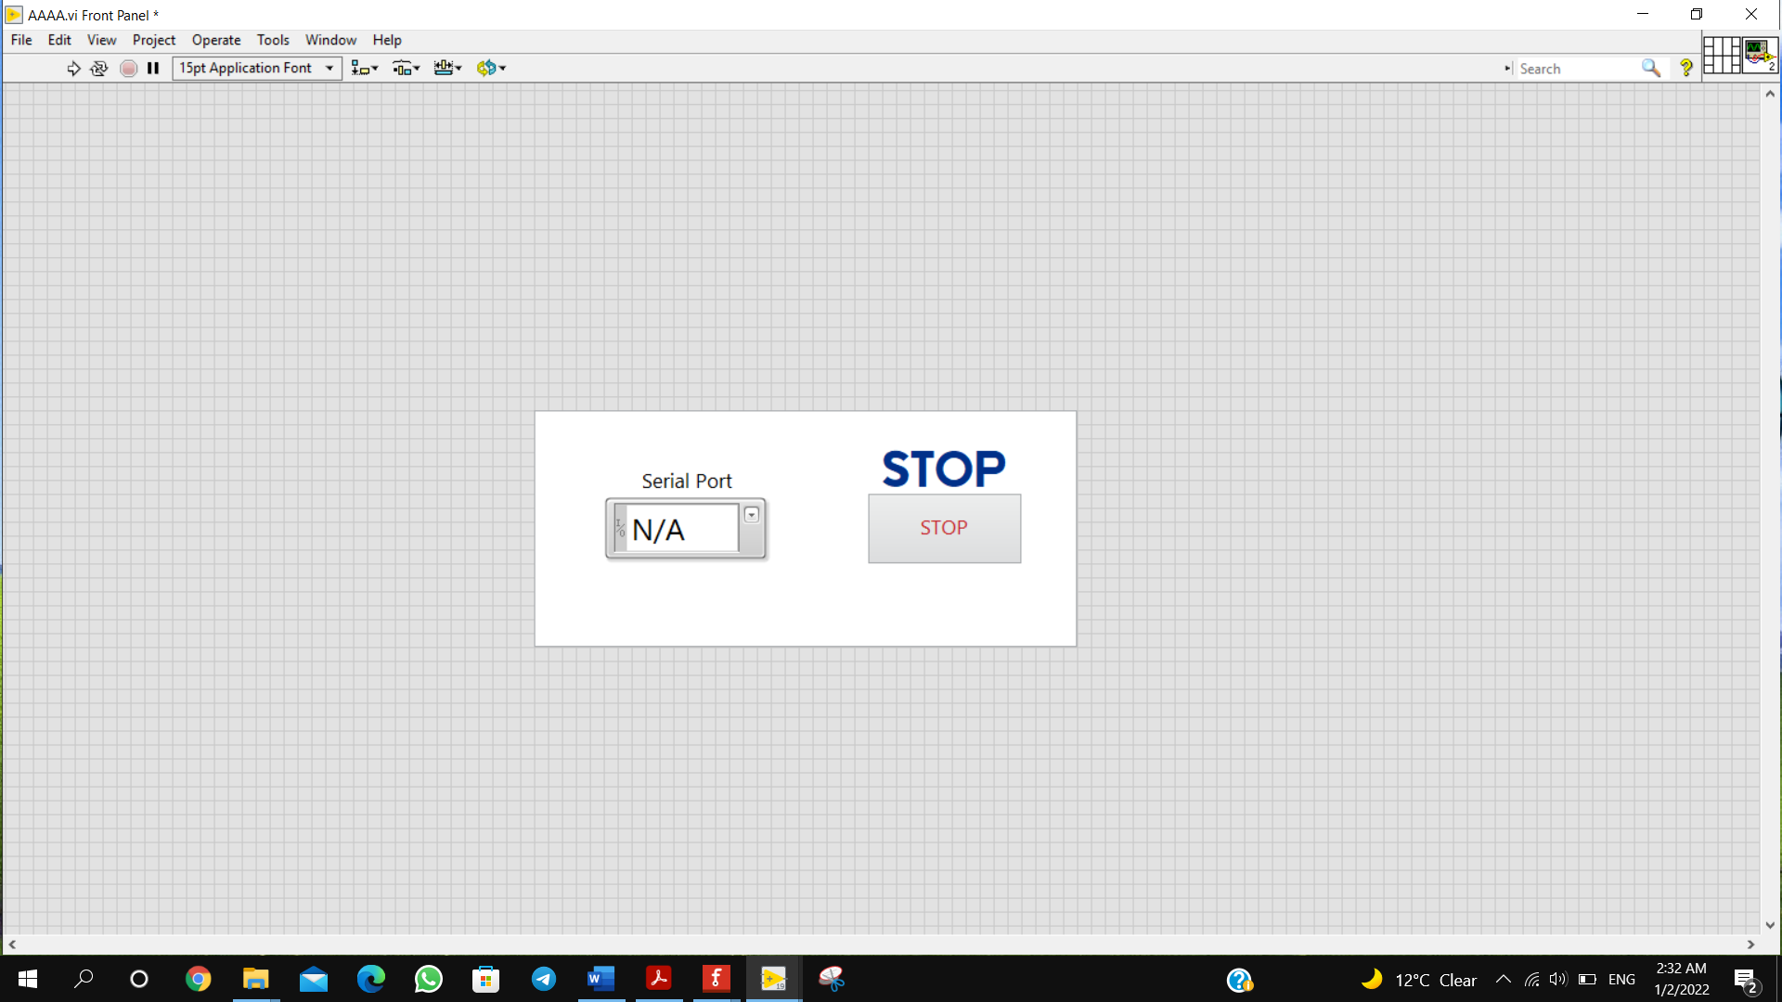
* **HARDWARE \**

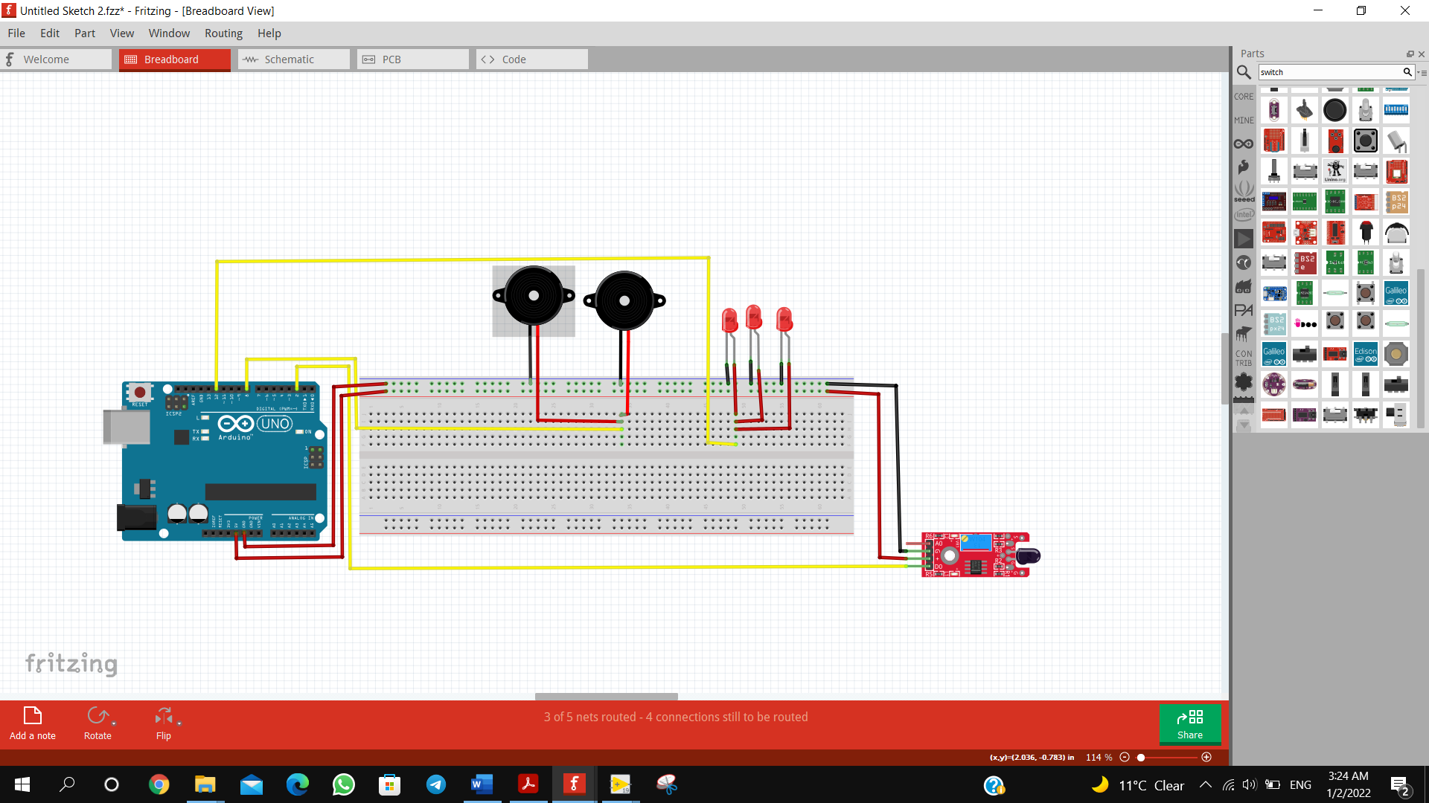First we connected the 5V and GND from Arduino to the sensor , and connect The signal pin (DO) to Pin 2 in Arduino which will act as digital read lately.

Next we connected 3 LEDs in parallel to Pin 12 in The Arduino.

Then connecting the 2 buzzer in parallel to Pin 8 in The Arduino.

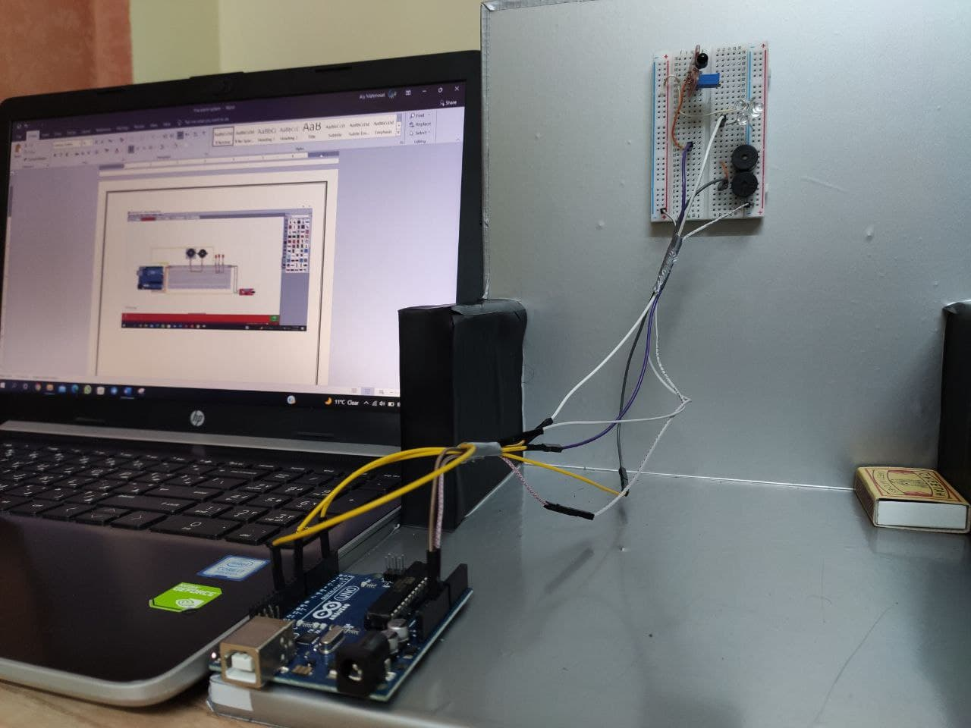Finally connecting the data and power cable to Arduino.

* Team Members :

1. MOHAMMAD SAAD HELMY
2. ALY MAHMOUD KHALLAF
3. MOHAMMAD MANSOUR MAHDI